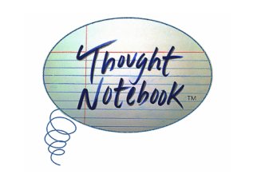

FOR IMMEDIATE RELEASE:

June 1st, 2015, Chicago, IL – Thought Notebook Journal based in Chicago, IL, will be releasing their fourth issue this summer after recently winning multiple awards for Indie Publishing.

Each issue of Thought Notebook Journal has a specific focus; the fourth will dive into the minds of societies from around the world and learn about how cycles apply to their lives relative to their own existence. Artists from US cities like Chicago and Portland, to Sweden and Canada ⎼ globally come together to bring the theme of the issue to life through a unique intersection of the written word and visual art. The columns in this issue are an output of the thought patterns that arise from the issue’s theme, putting on display observations from the cycles study.

Kat Lahr, Editor and Creative Director for Thought Collection Publishing says “There is something particularly special and personal about the circle and how its curves comfortably rule every aspect of our lives. Our research is finding that both the physical and emotional realm is guided by the cosmic principles of return, repetition, and periodicity.”

Each issue features an artist interview, and in this issue, fashion artist Gabrielle Zwick reflects on a personal journey that led her to develop a fashion line while reminding us of the cyclical nature of the fashion industry.

Thought Notebook Journal recently won multiple awards for Indie Publishing, including the eLit Book Awards and the Next Generation Indie Book Awards in Anthology, Science, Ebook Nonfiction & New Age categories.

Issues are available digitally for $1.99 and in print for $16.99. 10% of every sale gets donated to social change organizations, each issue supporting a different one.

http://thoughtnotebook.org/journal-issues.html

Contact Information
Thought Collection Publishing
PO Box 35192
Elmwood Park, IL. 60707
kat@thoughtcollection.org
ISSN 2334-1572 and 2334-1599

Thought Notebook Journal is based on a true story: humanity’s story.

