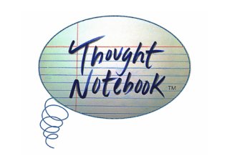

FOR IMMEDIATE RELEASE:

June 1st, 2014, Chicago, IL – Thought Notebook, the literary and visual arts journal based in Chicago, IL, will be releasing their 2nd volume this summer.

Thought Notebook provides a global platform for emerging and known literary and visual artists. The pieces in the journal all come from a range of artistic techniques, yet underlying similarities come forth. The columns are an output of the thought patterns that arise from the journal’s theme. Thought Notebook is based on a true story: humanity’s story.

Each volume of Thought Notebook has a specific theme; the June 2014 edition will be based around themes of “renewal.” From photography to painting to mixed media and the written word, each piece of art is representative of the respective artists’ take on renewal.

The artists range in all ages and come from starkly different backgrounds. Each issue features an artist interview, and in this issue, artist Shanara Sanders reflects on her personal journey from the confines of corporate work to the freedom of artistic expression.

Kat Lahr, the Creative Director and Editor of Thought Collection Publishing says, “This journal is part of our Human Thought Project, allowing us to delve into the minds of humanity and learn more about who we are by documenting into the notebook thoughts and expressions on particular subjects. I enjoy collectively working with literary and visual artists to bring our themes to life. Our growing community is filled with an enormous diversity of talent.”

Thought Notebook is available in print for $10.00 and digital for $0.99. 10% of all net profits get donated to social change organizations, each issue a different organization.

Contact Information
Thought Collection Publishing
PO Box 35192
Elmwood Park, IL. 60707
kat@thoughtcollection.org
ISSN 2334-1572 and 2334-1599

